**Meeting 1 – Thur 1st Oct**

Project decision:

PLAN 1 Remote-locking mechanism:

* Ask Duncan if he has a NFC sensor and a solenoid.
* Get Raspberry Pi – DR
* Can Pi drive solenoid?

PLAN 2 Fridge, Cooled Operating Online Lockbox, COOL:

* Thermometer
* Barcode scanner – possibly webcam
* Best before dates on food – possibly using touchscreen
* Online access to inventory, what’s going out of date?
* LED, to say close, open too long
* Extras:
* OCR to recognise best before dates
* Possible recommended meals – what’s going out of date?
* Temperature adjustment

**Meeting 2 – Tue 6th Oct**

* Emailed Duncan asking if our fridge idea is acceptable.
* Decided on Andrew’s fridge to work on.

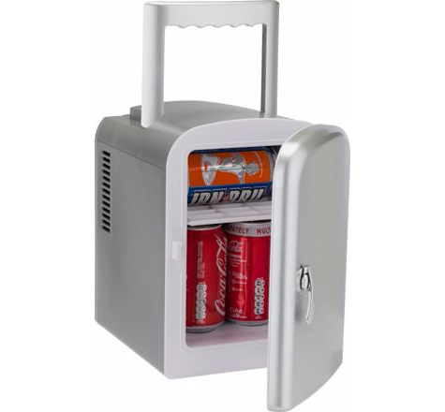

* Began identifying components we want
* Wrote up our report plan

**Meeting 3 – Thur 8th Oct**

* Began work on report. Wrote introduction.

**Meeting 4 – Tue 13th Oct**

* Paul has been working on LED prototypes.
* Github administration
* Trello administration
* Everything set up and good to go for writing the report on Thursday
* Alex will order Raspberry Pi camera tonight (for barcode scanning)

**Meeting 5 – Wed 14th Oct**

* Paul has made a mock up of the web page that will act as our interface to allow a user to communicate with the fridge

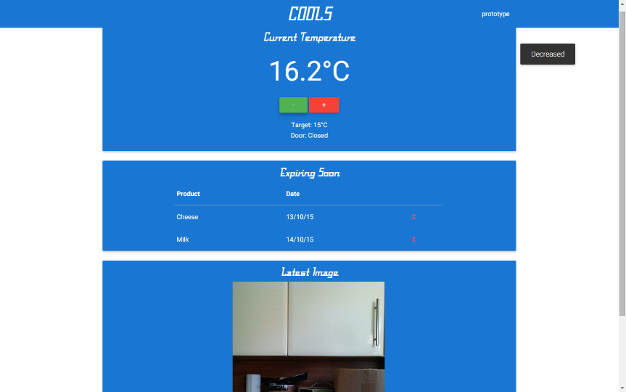

Figure 1: Computer version of web page

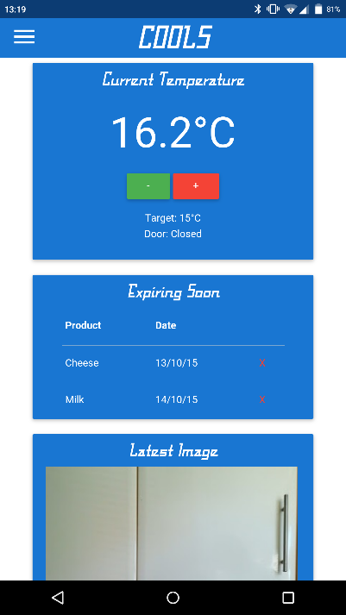

Figure 2: Mobile version of web page

* Andrew made some tables detailing the specifications of the Arduino and the Raspberry Pi Models 1A and 2B. This allowed us to make comparisons and justify our chosen board.
* Alex did some admin on the Github account, changing all the documents from .docx format to Markdown format to make them easier for us to make changes individually and push them.

**Meeting 6 – Thur 15th Oct**

* Scott has begun the Gantt chart to outline the plan for the rest of the project
* Alex finished the justification of our chosen board (why we chose the Pi over Arduino)
* Alex has also started working on the part of the report which describes our software design plan
* Paul has started outlining the hardware design
* Daniel has been making notes on our current progress
* Andrew has started working on the conclusion, which will be finished in full once we have completed the rest of the report.